Copper Queen Community Hospital
Community Health Implementation Plan
Fiscal Year 2020-2023

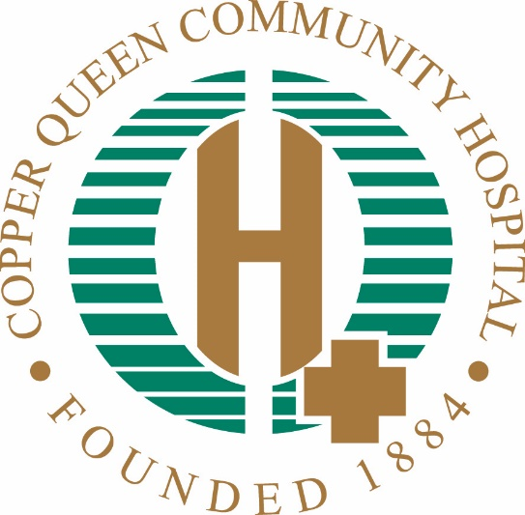

Table of Contents

Background

How the Implementation Plan was Developed

County Health Needs and Priorities Identified During CHNA

Southeast Cochise County Area Health Needs Identified During CHNA

Top Health Priorities (Areas of Focus) determined by CQCH

Action Plan

Identified Needs Not Addressed by This CHIP

Background

In 2012-13, Cochise Health and Social Services (CHSS) completed its first Community Health Needs Assessment (CHNA) and Community Health Improvement Plan (CHIP), with technical and funding support from the Arizona Department of Health Services. Building on the 2012 assessment, CHSS embarked on a collaborative approach to conduct the 2016 health assessment, partnering with the Legacy Foundation of Southeast Arizona, Benson Community Hospital, Copper Queen Community Hospital and Northern Cochise Community Hospital to bring together residents and community leaders, nonprofit and social service agencies, governmental institutions and federally qualified community health centers to harness their collective resources, energy and expertise to identify and prioritize the major issues threatening the health and well-being of Cochise County residents. In 2019 CQCH set out on their own to complete their first independent CHNA since 2012.

Those CHNA community partners included Cenpatico Integrated Care, Chiricahua Community Health Centers, Inc., Community Food Bank of Southern Arizona, Fort Huachuca Community Health Promotion Council, Sierra Vista Be Healthy!, Southeastern Arizona Government Organization, Southeastern Arizona Behavioral Health Services, St. Vincent de Paul in Douglas, St. Vincent de Paul in Sierra Vista, Rural Accent/Bowie Community Food Pantry and University of Arizona Cooperative Extension.

The 2020 assessment is pending submittal and approval by the CQCH board of directors. This assessment is available for public review on the hospital’s website at www.cqch.org. As part of the CHNA, a plan is required outlining the needs identified through the CHNA; as part of this plan the hospital must address the needs that will be met over the next three years, with specific objectives and strategies. Additionally, the plan must identify those needs that will not be addressed, along with justification for excluding them as part of the implementation plan. This Community Health Implementation Plan (CHIP) will address these steps.

How the Implementation Plan was Developed

CHNA Process
The CHNA was completed at the end of the 2020 fiscal year. Individuals representing multiple agencies and several population groups provided direct input and feedback into the process. The process and steps are outlined in the CHNA report made widely available to the public on the CQCH website at www.cqch.org. Localized results for the CQCH service area were reviewed. A list of priorities was defined by a combination of community members and the CQCH staff. These priorities will be the focus of the implementation plan for CQCH over the next three years.

Health Concerns Identified for Cochise County at the start of the CHNA:
- More mental/behavioral health services
- More medical care – primary care and specialists
- Transportation
- Better access to healthier foods
- More services and resources of all kinds
- Greater awareness about resources through education and communication
- More collaboration and working together
- Economic development and diversity

Health Needs Identified for Bisbee during the CHNA via survey:
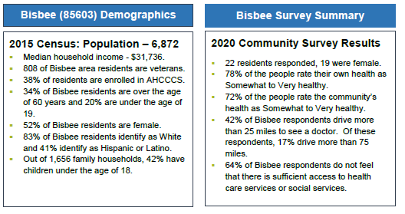
To learn what matters most to people in regards to achieving a high quality of life Question 1 (Q1) asked respondents to select three factors from a list of 21 options. From the Bisbee area residents, the three most important factors in improving their quality of life in their community are:
• Good jobs and healthy economy
• Good schools
• Access to affordable health care

Question two asked residents to identify from a list of 25 health concerns the biggest health problems in the community. The top three health problems selected by residents responding to the survey are:
• Substance/drug abuse
• Mental health
• Aging problems

Question three (Q3) asked residents to select from a list of 15 options the top three risky behaviors in their community. Residents who responded to the survey selected:
• Drug abuse
• Alcohol abuse
• Being overweight

Health Needs Identified for Douglas during the CHNA via survey:
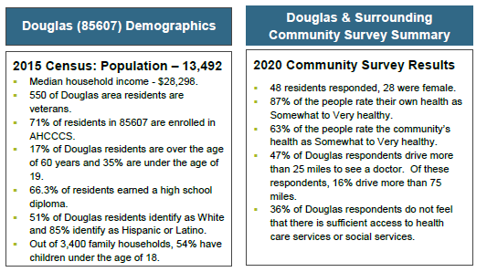
To learn what matters most to people in regards to achieving a high quality of life Question 1 (Q1) asked respondents to select three factors from a list of 21 options. From the Douglas residents the three most important factors in improving their quality of life in their community are:
- Good jobs and healthy economy
- Low crime/safe neighborhoods
- Good place to raise children

Question two (Q2) asked residents to identify from a list of 25 health concerns the biggest health problems in the community. The top three health problems selected by residents responding to the survey are:
- Cancer
- Diabetes
- Drug abuse

Question three (Q3) asked residents to select from a list of 15 options the top three risky behaviors in their community. Residents who responded to the survey selected:
- Drug abuse
- Alcohol abuse
- Being overweight

Health Needs Identified for Palominas during the CHNA via survey:

To learn what matters most to people in regards to achieving a high quality of life Question 1 (Q1) asked respondents to select three factors from a list of 21 options. From the Palominas residents the three most important factors in improving their quality of life in their community are:
- Good place to raise children
- Good jobs and healthy economy
- Low crime/safe neighborhoods

Question two (Q2) asked residents to identify from a list of 25 health concerns the biggest health problems in the community. The top three health problems selected by residents responding to the survey are:
- Mental health
- Diabetes
- Drug abuse

Question three (Q3) asked residents to select from a list of 15 options the top three risky behaviors in their community. Residents who responded to the survey selected:
- Drug abuse
- Alcohol abuse
- Being overweight

Top three problems as determined by Bisbee group:
A Bisbee community meeting was held November 30, 2019. Twenty Two community members were in attendance for the presentation of Cochise County community health data and the midpoint survey results for the county and Bisbee area. After hearing the presentation and discussing the county health data and survey results, the community members ranked the following issues as the top three problems facing Bisbee residents:
1. Alcohol/Substance Abuse
2. Good Jobs/Healthy Economy
3. Obesity & Healthy Lifestyles

Top three problems as determined by Douglas group:
A Douglas community meeting was held November 30, 2019. Fourty Eight community members were in attendance for the presentation of Cochise County community health data and the midpoint survey results for the county and Douglas area. After hearing the presentation and discussing the county health data and survey results, the community members ranked the following issues as the top three problems facing Douglas residents:
1. Mental Health/Drug Abuse
2. Teen Pregnancy/Birth Control
3. Healthy Eating/Diabetes - Obesity

Top three problems as determined by Palominas group:
A Palominas community meeting was held November 30, 2019. Eighteen community members were in attendance for the presentation of Cochise County community health data and the midpoint survey results for the county and Douglas area. After hearing the presentation and discussing the county health data and survey results, the community members ranked the following issues as the top three problems facing Douglas residents:
1. Mental Health/Drug Abuse
2. Low crime/safe neighborhoods
3. Healthy Eating/Diabetes - Obesity
Top health priorities as determined by CQCH:

Substance Abuse / Misuse
Medicaid utilization data revealed that mental health and substance use disorders are a major contributor to the poor health of Cochise County residents. Mental health and physical health are inextricably linked, and research has shown a link between depression and chronic diseases and health conditions, including diabetes and cancer, which are two of the leading causes of death in Cochise County. To increase coordinated care for substance abuse, Copper Queen Community Hospital is participating in a federal grant to further develop a network to improve outcomes in opioid misuse and management – a major new crisis in Arizona -- for rural communities across Southern Arizona.

Diabetes and Obesity, including Healthy Eating
Unhealthful individual behaviors like smoking, lack of physical activity, and poor eating habits are major contributors to the leading chronic diseases. The United States Department of Agriculture (USDA) catalogs who has limited access to healthy food by determining what percentage of low-income residents live close to a grocery store (within 10 miles in rural areas). The lack of healthy food choices, lack of physical activity and obesity all contribute to the county’s high rate of diabetes.

Good Jobs and a Healthy Economy
Health is influenced by a number of factors including social and economic factors, including where people live. People who live in rural areas are at a higher risk of having poor health. Cochise County is one of two counties in Arizona with a declining census; all other counties are experiencing population growth. In addition, approximately 28 percent of the county’s children are living in poverty, which is an indicator for an increased risk of mortality, prevalence of medical conditions and disease incidence, and poor health behaviors.

Action Plan
CQCH is committed to quality healthcare close to home. Additionally, the hospital has a commitment to address challenges in a proactive manner. A number of needs and challenges have been identified through the CHNA process. Currently, the hospital is working to meet many of the needs identified through existing services and venues, including a 24-hour emergency department with a Level IV Trauma Center, imaging and respiratory services, an outpatient medical center, including a satellite clinic to serve a population in Palominas, a specialty clinic with providers who travel from Tucson to provide specialty services in 16 different areas, inpatient and outpatient rehabilitation services – including physical, occupational, and speech therapy, and an onsite full-service laboratory. To address the health care needs of Douglas, whose only hospital closed, Copper Queen Community Hospital opened a free-standing emergency department in Douglas. Several strategies have been developed to further enhance, educate, and address many of the needs identified in the CHNA. These strategies are noted below:

Priority: Substance Abuse / Misuse
Objective 1: Provide education and best practices to assist in decreasing opioid misuse and abuse in Southeast Arizona.

Strategies:
1. CQCH will partner with a behavioral health providers and first responders to fight opioid misuse in Southeastern Arizona. CQCH and Southern Arizona Hospital Alliance (SAHA) will disseminate Arizona Opioid Prescribing Guidelines across the network; conduct patient pain management needs assessment among the network and develop a shared database of patient pain management; develop and share opioid misuse communications plan; design or adapt community education strategies; and disseminate information on best practices regarding treatment of opioid misuse.
2. CQCH will work with Douglas and Bisbee school districts to educate middle school students in the dangers of drug and opioid use, whether prescribed or illegal.
3. CQCH will create partnerships with law enforcement and first responders to increase knowledge, and improve strategies and education on reducing opioid misuse.
Anticipated Impact: Through these efforts, up to an estimated 400 community residents, including providers, will receive education on appropriate use of opioid pain medications, as well as the effects and best practices for treatment of misuse and abuse of opioids.

Objective 2: Build relationships with Mental Health Providers to increase coordinated care for Southeast Arizona residents.
Strategies:
1. CQCH is partnering with our Southern Arizona Hospital Alliance (SAHA) members to build a network of behavioral health providers to fight opioid misuse in Southeastern Arizona.
2. Design and test a process for integrating behavioral health screening and referrals for emergency departments or other healthcare providers.

Anticipated Impact: A goal is to develop a coordinated care plan between network hospitals and behavioral health providers to decrease opioid and other substance abuse and misuse.

Priority: Diabetes and Obesity, including Healthy Eating
Objective 1: Provide education and care that is safe, timely, effective, efficient, equitable, and patient-focused.
Strategies:
1. CQCH currently provides healthy low fat and calorie meals to the general public as well as patients and employees in the CQCH cafeteria.
2. CQCH will promote and educate residents on healthy living activity options in Douglas and Bisbee. CQCH sponsored new playground equipment ($38,000) at the local park to encourage children and parents to engage in healthy outside activities. CQCH purchased solar heaters ($20,000) for the Bisbee outdoor pool to lengthen the time the pool is available to the community.
3. CQCH provides weekly Weight Watchers classes open to the public to manage weight and encourage healthy eating.
4. CQCH provides lifestyle classes targeted to people with chronic diabetes to help manages their care and improve their lifestyle.
Anticipated Impact: Through the education efforts of the hospital, we hope to prevent residents from becoming diabetic or obese through diet and exercise. And for those who already have chronic illness, we hope to reduce further complications of diabetes and obesity.

Priority: Good Jobs and a Healthy Economy
Objective 1: Be the employer of choice in the service area providing jobs that offers a living wage and affordable benefits.
Strategies:
1. CQCH currently employs over 350 people in good paying jobs that exceed the average for their peer group in rural Arizona.
2. CQCH will seek to expand services to accommodate the community needs that will result in additional employment opportunities. Over 20 full time equivalent positions have been added in Bisbee in the last year.
3. CQCH will seek to expand services in Douglas to accommodate community needs. Over 35 full time equivalent positions were added in Douglas with the opening of the Douglas Emergency Department.
4. CQCH will work with the local school districts through health clubs that promote working in the health care industry.
Anticipated Impact: Through continued expansion and ability to provide excellent benefits and wages that exceed our competitors, CQCH will be the provider of choice for Southeast Arizona and provide positive economic impact in the community.

Identified Needs Not Addressed by This CHIP

A number of issues were identified which are currently being funded and addressed through other agencies. Additionally, other agencies are better equipped to address these issues. CQCH lacks the providers, equipment, and financial resources to address all community needs. This is a poor area on the border of Mexico that has chronic social service and economic needs that no one institution has the resources to address. We do the best we can with the resources we have.

Copper Queen Community Hospital is committed to quality and affordable healthcare close to home. As such, it will continue to strive toward eliminating barriers to treatment in the community that would prevent the provision of appropriate, safe, and adequate healthcare to the population it serves.

